Roll no. : 23112022

C program documentation extractor to streamline the process of understanding and maintaining C codebases.

Note :
- Provided program extracts content between delimeters (begins with /* and ends with */) as it is including spaces, tabs, special characters and newline i.e everything enclosed in delimeters will be considered as part of documentation.

- Even though c doesn’t support nested comments, given program handles nested documentation comments also.

Program :

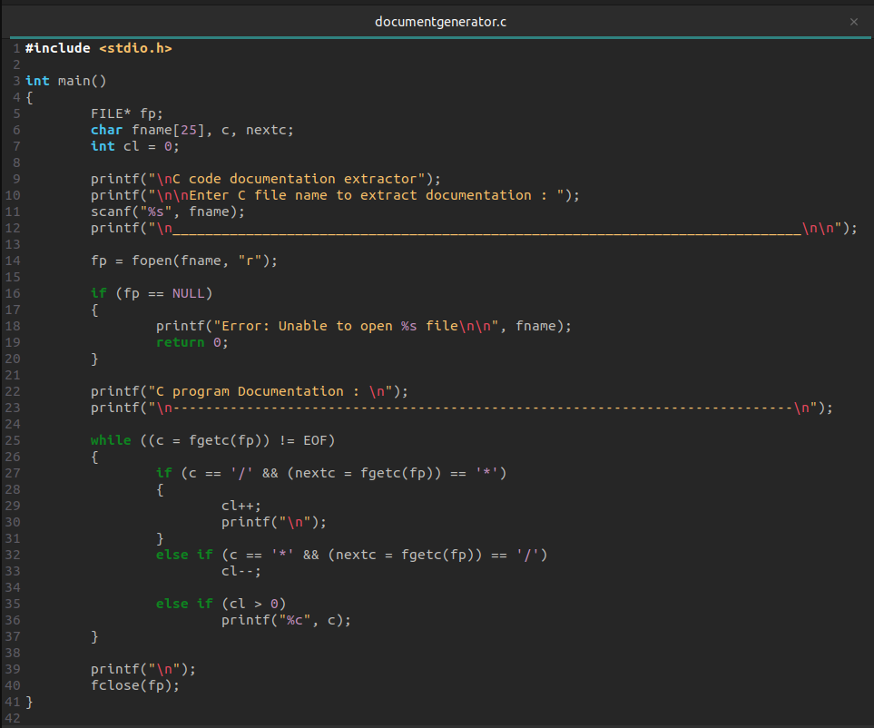
input file :
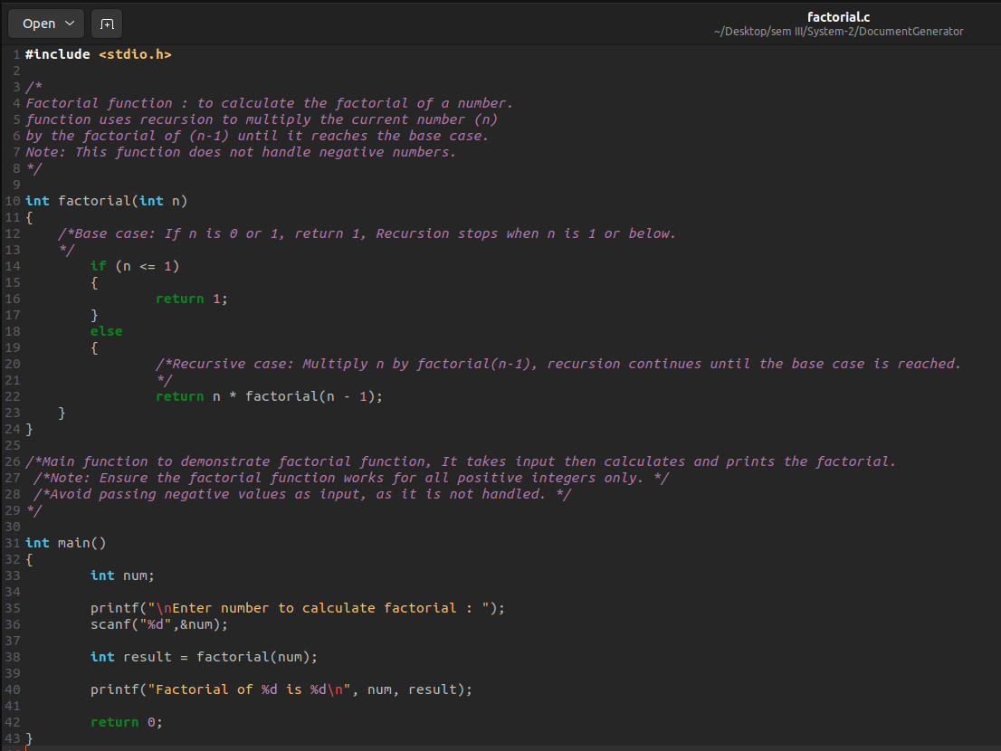

Output :

